Downloading...
From: https://drive.google.com/uc?id=1VJaDVtDUtKQMmhRAqr3t-fgng899ZdRV
To: /content/Python Application Usage Log Data Set.xlsx
100%|██████████| 1.68M/1.68M [00:00<00:00, 142MB/s]
ADF Statistic (train): -9.6464, p-value: 0.0000
Any object dtypes in X_train_s? -> False
Remaining NaNs in X_train_s? -> 0
X columns used: 47
Checked order (0, 1, 0), AIC=68373.38, LB p10=0.000, p20=0.000
Checked order (0, 1, 1), AIC=67233.42, LB p10=0.000, p20=0.000
Checked order (0, 1, 2), AIC=67145.17, LB p10=0.000, p20=0.000
Checked order (0, 1, 3), AIC=67116.24, LB p10=0.000, p20=0.000
Checked order (1, 1, 0), AIC=67697.32, LB p10=0.000, p20=0.000
Checked order (1, 1, 1), AIC=67132.85, LB p10=0.000, p20=0.000
Checked order (1, 1, 2), AIC=67106.51, LB p10=0.000, p20=0.000
Checked order (1, 1, 3), AIC=67081.27, LB p10=0.000, p20=0.000
Checked order (2, 1, 0), AIC=67393.48, LB p10=0.000, p20=0.000
Checked order (2, 1, 1), AIC=67098.23, LB p10=0.000, p20=0.000
Checked order (2, 1, 2), AIC=67103.11, LB p10=0.000, p20=0.000
Checked order (2, 1, 3), AIC=67030.76, LB p10=0.000, p20=0.000
Checked order (3, 1, 0), AIC=67326.39, LB p10=0.000, p20=0.000
Checked order (3, 1, 1), AIC=67049.08, LB p10=0.000, p20=0.000
Checked order (3, 1, 2), AIC=67096.21, LB p10=0.000, p20=0.000
Checked order (3, 1, 3), AIC=67080.40, LB p10=0.000, p20=0.000

Selected order by AIC (no model fully passed Ljung–Box): (2, 1, 3), AIC=67030.76

SARIMAX Results
==============================================================================
Dep. Variable: daily_active_users No. Observations: 4631
Model: SARIMAX(2, 1, 3) Log Likelihood -33462.382
Date: Wed, 15 Oct 2025 AIC 67030.764
Time: 08:39:23 BIC 67372.055
Sample: 08-01-2012 HQIC 67150.854
- 04-05-2025
Covariance Type: oim
===============================================================================================
coef std err z P>|z| [0.025 0.975]
-----------------------------------------------------------------------------------------------
session_count 1040.3740 8.515 122.185 0.000 1023.685 1057.063
avg_session_duration 17.5459 16.858 1.041 0.298 -15.496 50.587
like_count 12.1782 15.613 0.780 0.435 -18.423 42.779
share_count 5.5325 13.516 0.409 0.682 -20.959 32.024
download_count -11.4572 16.416 -0.698 0.485 -43.632 20.717
comment_count -12.4416 15.736 -0.791 0.429 -43.283 18.400
error_count 11.5481 6.568 1.758 0.079 -1.325 24.421
is_weekend -7.4670 3.475 -2.149 0.032 -14.277 -0.657
release_flag -1.4720 4.570 -0.322 0.747 -10.430 7.486
app_Business Courses app 1.0184 6.331 0.161 0.872 -11.390 13.427
app_Facebook 3.3381 11.463 0.291 0.771 -19.129 25.805
app_Health Courses app -3.4592 5.621 -0.615 0.538 -14.476 7.558
app_Instagram 2.2690 10.114 0.224 0.822 -17.554 22.092
app_LinkedIn 6.7377 7.368 0.914 0.360 -7.703 21.178
app_Online Course app -2.5693 60.002 -0.043 0.966 -120.170 115.032
app_Pinterest -1.8102 6.865 -0.264 0.792 -15.265 11.645
app_Programming Courses app 0.5970 4.796 0.124 0.901 -8.803 9.997
app_Quora 5.9865 6.638 0.902 0.367 -7.023 18.996
app_Quora Website 0.5927 4.849 0.122 0.903 -8.911 10.096
app_Reddit 3.0237 7.082 0.427 0.669 -10.857 16.904
app_Science Courses app 6.0711 4.637 1.309 0.190 -3.017 15.159
app_Snapchat 9.7269 6.287 1.547 0.122 -2.596 22.050
app_Telegram 11.2293 5.704 1.969 0.049 0.050 22.408
app_Threads -2.3822 5.341 -0.446 0.656 -12.851 8.086
app_TikTok 0.8102 7.279 0.111 0.911 -13.456 15.076
app_Twitter 3.7385 7.168 0.522 0.602 -10.310 17.787
app_WeChat 7.5378 5.166 1.459 0.145 -2.588 17.663
app_WhatsApp 11.5146 4.988 2.308 0.021 1.738 21.291
app_X (formerly Twitter) 15.0612 4.960 3.037 0.002 5.340 24.782
app_YouTube 2.6455 6.131 0.431 0.666 -9.371 14.662
dow_1.0 -2.1623 5.356 -0.404 0.686 -12.661 8.336
dow_2.0 -13.3698 5.860 -2.282 0.023 -24.855 -1.885
dow_3.0 -7.1731 5.907 -1.214 0.225 -18.751 4.405
dow_4.0 -5.5764 5.904 -0.944 0.345 -17.149 5.996
dow_5.0 -9.0830 3.697 -2.457 0.014 -16.330 -1.836
dow_6.0 -0.7006 3.344 -0.210 0.834 -7.254 5.853
mon_2.0 12.6263 14.865 0.849 0.396 -16.509 41.762
mon_3.0 -5.6671 15.387 -0.368 0.713 -35.825 24.490
mon_4.0 -17.7823 15.859 -1.121 0.262 -48.865 13.300
mon_5.0 -15.0141 16.526 -0.909 0.364 -47.404 17.375
mon_6.0 13.3876 15.374 0.871 0.384 -16.745 43.520
mon_7.0 37.0574 15.819 2.343 0.019 6.053 68.062
mon_8.0 22.3057 16.697 1.336 0.182 -10.420 55.031
mon_9.0 3.2948 16.520 0.199 0.842 -29.083 35.673
mon_10.0 7.8226 15.841 0.494 0.621 -23.224 38.870
mon_11.0 -10.3600 15.169 -0.683 0.495 -40.091 19.371
mon_12.0 18.3783 14.341 1.282 0.200 -9.729 46.486
ar.L1 0.4615 0.233 1.981 0.048 0.005 0.918
ar.L2 0.3528 0.194 1.818 0.069 -0.028 0.733
ma.L1 -1.0331 0.231 -4.480 0.000 -1.485 -0.581
ma.L2 -0.1977 0.323 -0.612 0.541 -0.831 0.436
ma.L3 0.2452 0.098 2.498 0.012 0.053 0.438
sigma2 1.139e+05 2368.911 48.093 0.000 1.09e+05 1.19e+05
===================================================================================
Ljung-Box (L1) (Q): 0.00 Jarque-Bera (JB): 709472.01
Prob(Q): 0.98 Prob(JB): 0.00
Heteroskedasticity (H): 0.14 Skew: -0.86
Prob(H) (two-sided): 0.00 Kurtosis: 63.65
===================================================================================

Warnings:
[1] Covariance matrix calculated using the observed information matrix (complex-step) described in Harvey (1989).
[2] Covariance matrix is singular or near-singular, with condition number 7.44e+20. Standard errors may be unstable.
Test MAE: 226.315
Test RMSE: 318.043
Test MAPE: 12.34%
Test Accuracy (100 - MAPE): 87.66%
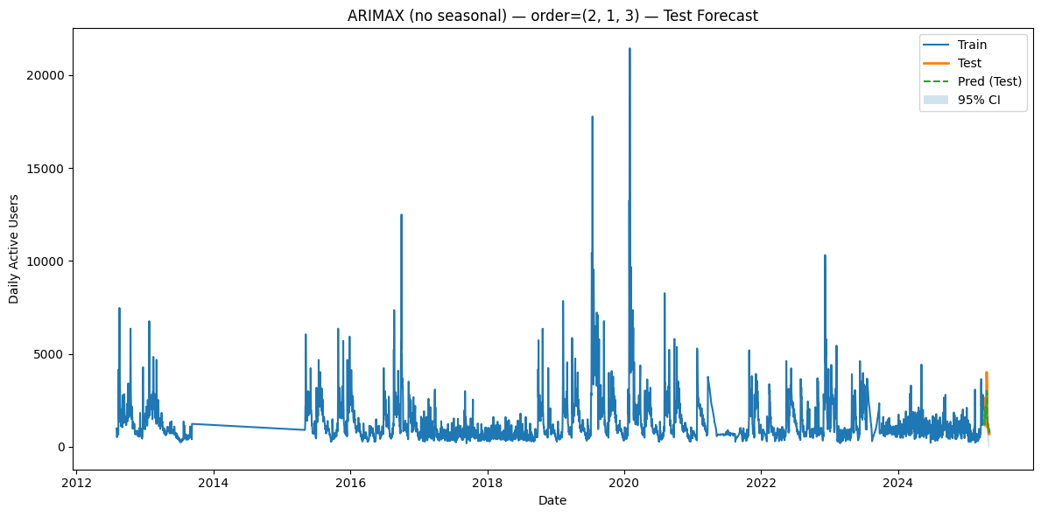

--------------------------------------------------------------------------------

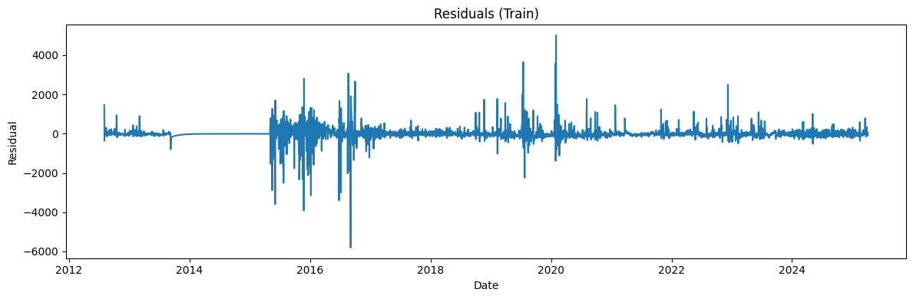

--------------------------------------------------------------------------------

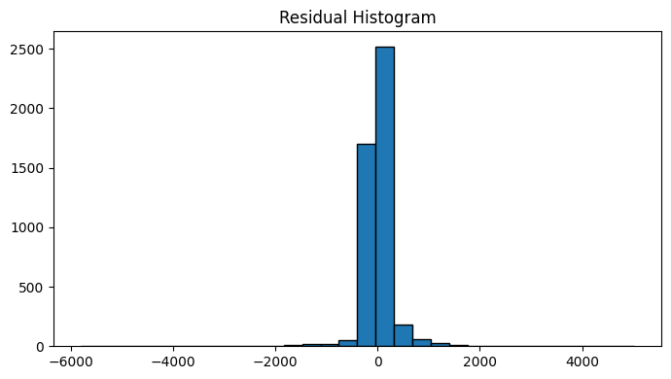
Ljung-Box stats & p-values (train):
lb_stat lb_pvalue
10 33.875368 1.938934e-04
20 103.911982 2.496693e-13

--------------------------------------------------------------------------------

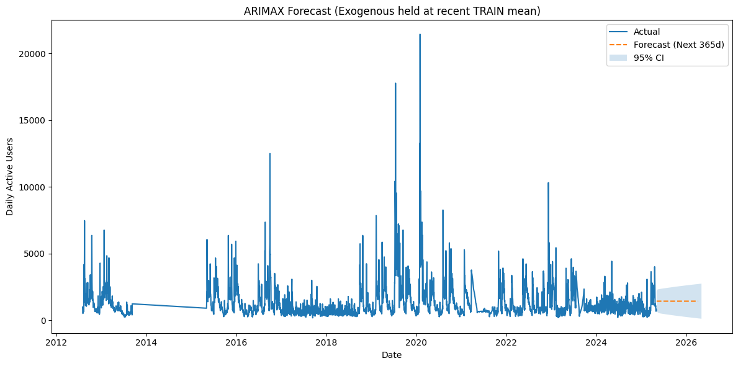

Accuracy (100 - MAPE): 87.66%
MAPE: 12.34% sMAPE: 12.69%
MAE: 226.315 RMSE: 318.043 R²: 0.863
MASE (vs naive-1): 0.696
Directional Accuracy: 78.57%

